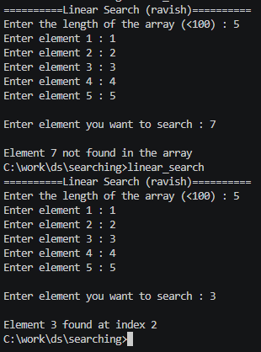 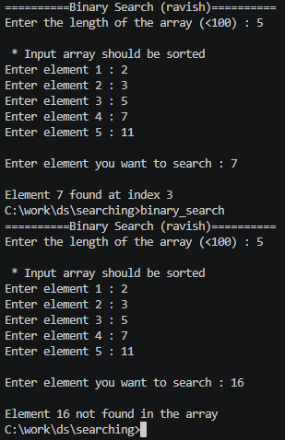

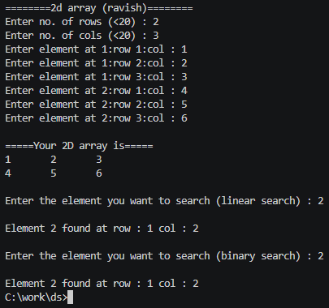 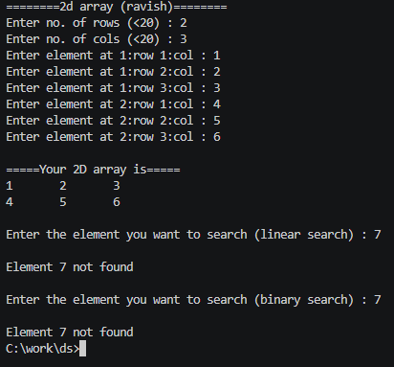 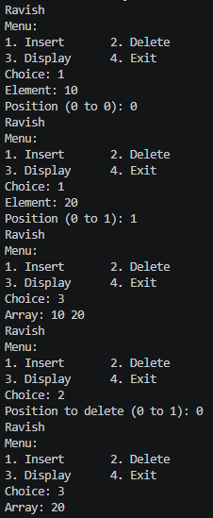

INDEX

|  |  |  |  |  |
| --- | --- | --- | --- | --- |
| S. No. | Date | Program | Page No. | Remarks |
|  |  |  |  |  |
|  |  |  |  |  |
|  |  |  |  |  |
|  |  |  |  |  |
|  |  |  |  |  |
|  |  |  |  |  |
|  |  |  |  |  |
|  |  |  |  |  |
|  |  |  |  |  |
|  |  |  |  |  |
|  |  |  |  |  |
|  |  |  |  |  |
|  |  |  |  |  |
|  |  |  |  |  |
|  |  |  |  |  |
|  |  |  |  |  |
|  |  |  |  |  |
|  |  |  |  |  |
|  |  |  |  |  |
|  |  |  |  |  |